IoT Guide

Daniel Alves Barreleiro

Unzip the archive Cet235-Resources-Pack.zip into a known directory, this archive contains various file to prepare the IoT device.

Open a command prompt in the IoT VM and access the location where the unzipped files from the Cet235-Resources-Pack.zip are.

Connect one of the Huzzah32 boards to one of the PC USB port with a USB cable. The VM software will now ask you to which device to connect to, select the Virtual Machine.

Once the Huzzah32 is connected, you may see some LEDs flashing, open the app USBDeview in the IoT VM. This app shows all the devices connected to your PC. You should see a device with the Description “Silicon Labs…,” make sure to note the drive letter/port number, this is your Huzzah32 port connection.

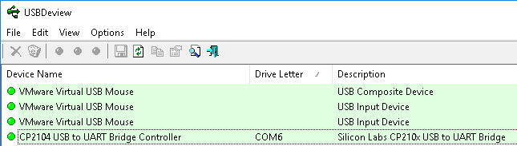Go back to the command prompt in the IoT VM and make sure you are in the correct directory ***C:\Users\Ada\Desktop\Cet235-Resources-Pack>.***

Type in the following command and replace COM?? With the COM port your Huzzah32 is connected to, and press enter.

***prep_esp32.bat COM6***

You will be prompted to press Y to continue.

When completed you should see something like below:

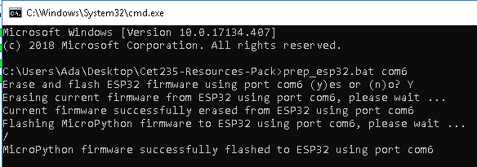

If this fails, try reconnecting the USB cable or try another cable or board.

Now, to have a fully set up Huzzah32 and sensors, we need to connect some cables, to connect the LEDs, connect the right-most pin to the 7th pin along the left from the right most pin. You can see an example below.

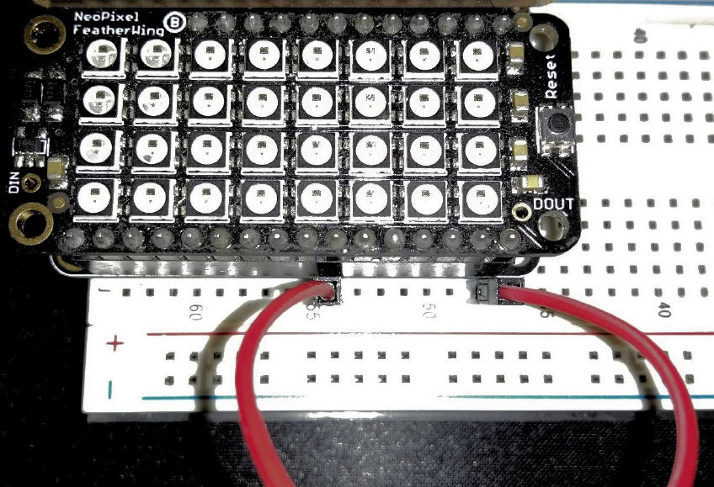

Now to connect the sensors, locate the Huzzah32 board, which is the top one, and locate the SCL pin, which is the second one counting from the right-most pin.

In the image below, the SCL pin is connected with blue wires, make sure to connect the Huzzah32 SCL pin to the Sensor SCL pin which is easily identified.

For the SDA pin, the image below has green wires, make sure to connect the Huzzah32 SDA pin to the Sensor SDA pin which is easily identified.

**You can use any cable colours, the colours used and mentioned are just for guidance.**

Now connect a wire to the blue line on the top of the breadboard and the other end of the wire to the GND pin on the sensor.

Connect another wire to the red line on the top of the breadboard and the other end of the wire to the 2-6V pin on the sensor.

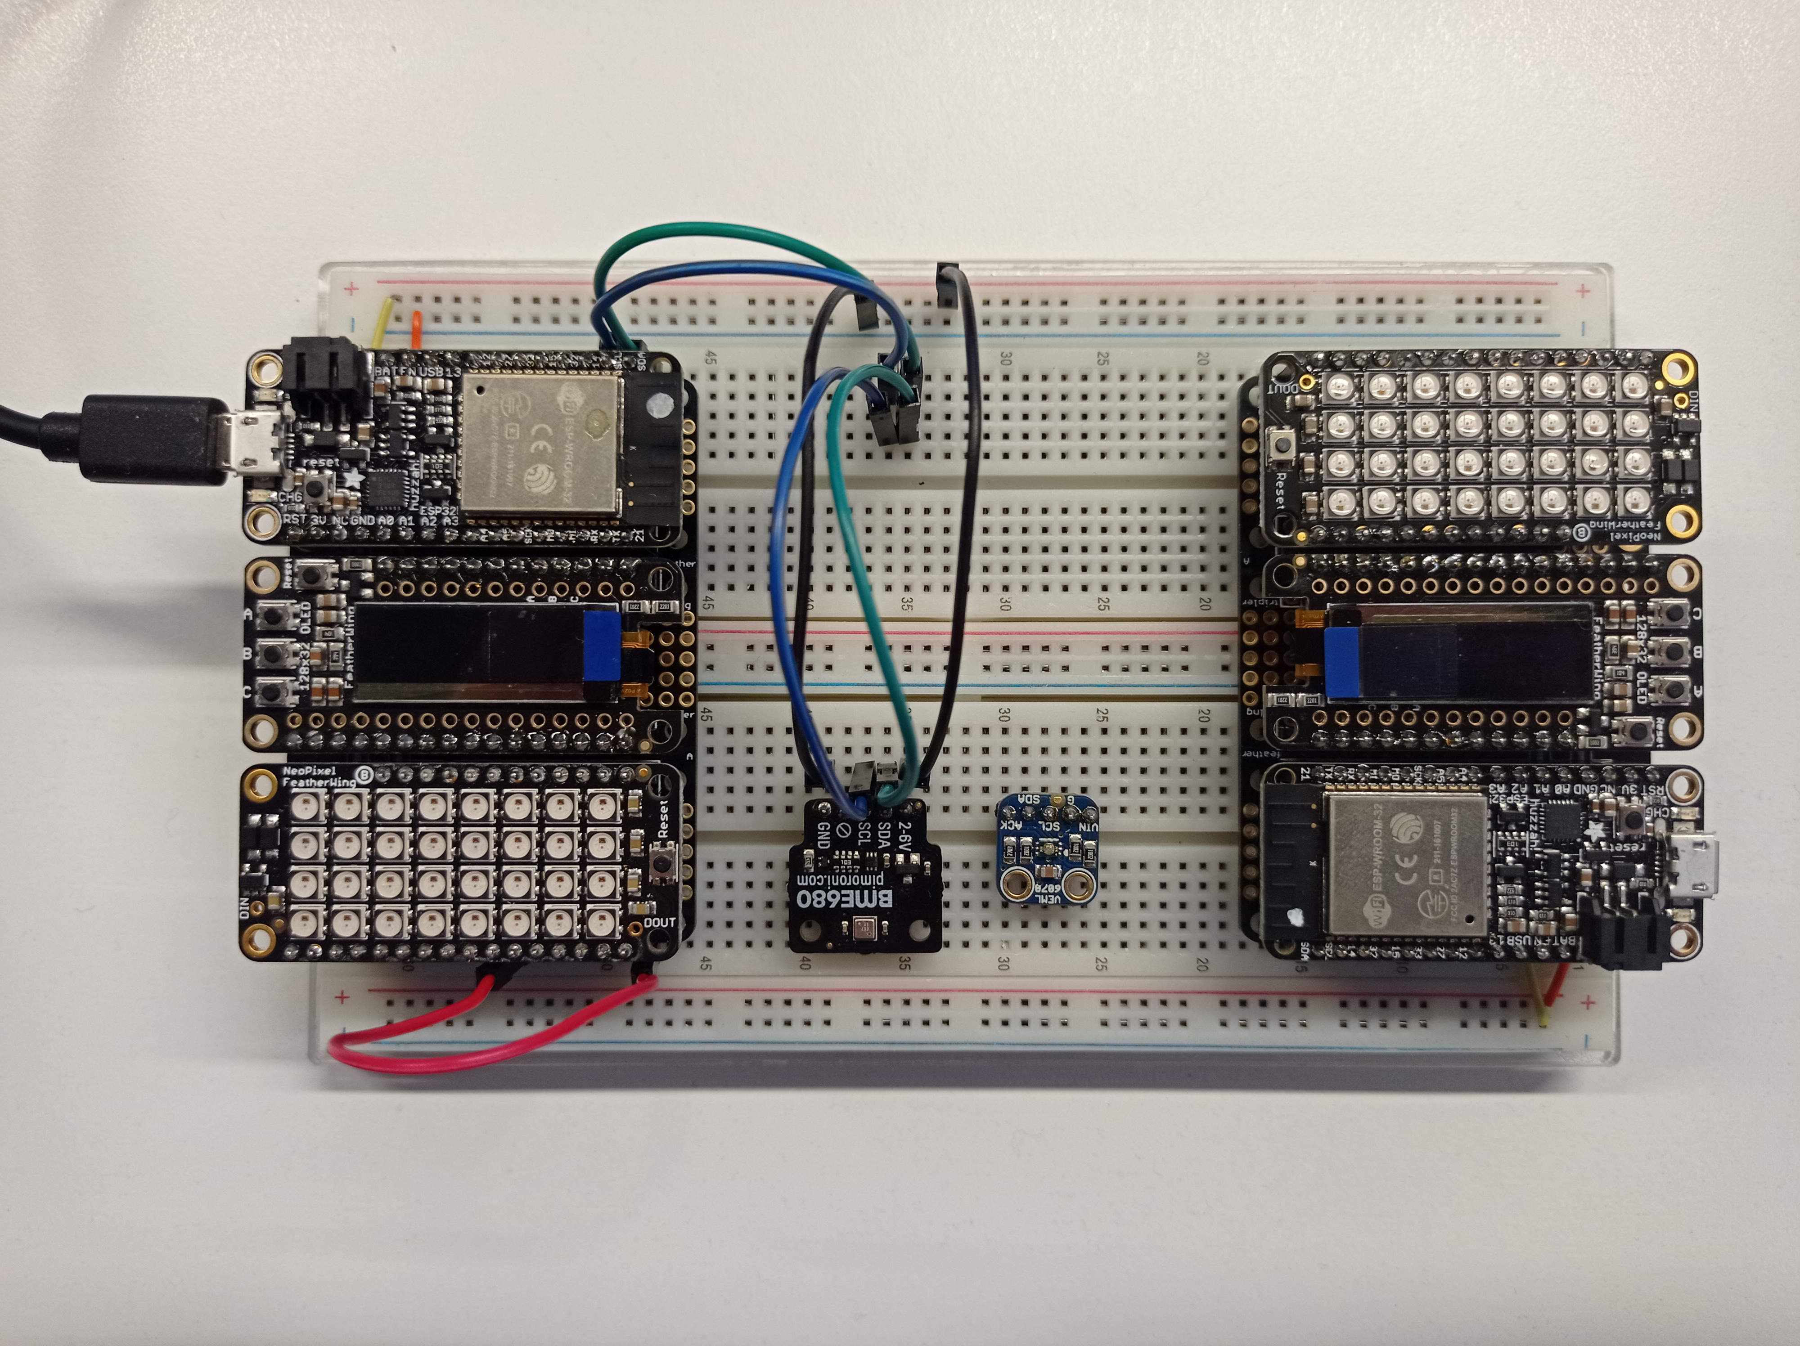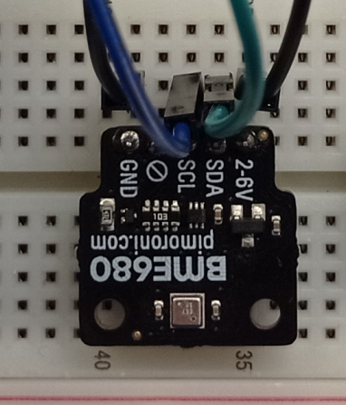

Now get the python file provided, copy it to the directory called **code** which is in the same directory as the file we just used to prepare the Huzzah32.

Now to run the code on the Huzzah32, make sure it is connected to the IoT VM and it has successfully been prepared, if it is not open, open again the command prompt and run the following command:

**ampy –p com?? run IoT-Prot-System.py**

If it runs successfully, you should see the screen on the Huzzah32 turn on and when it is ready, show some data on the screen, like in the picture below.

**If this does not happen and there is an error on the command prompt, then a cable must be connected wrong.**

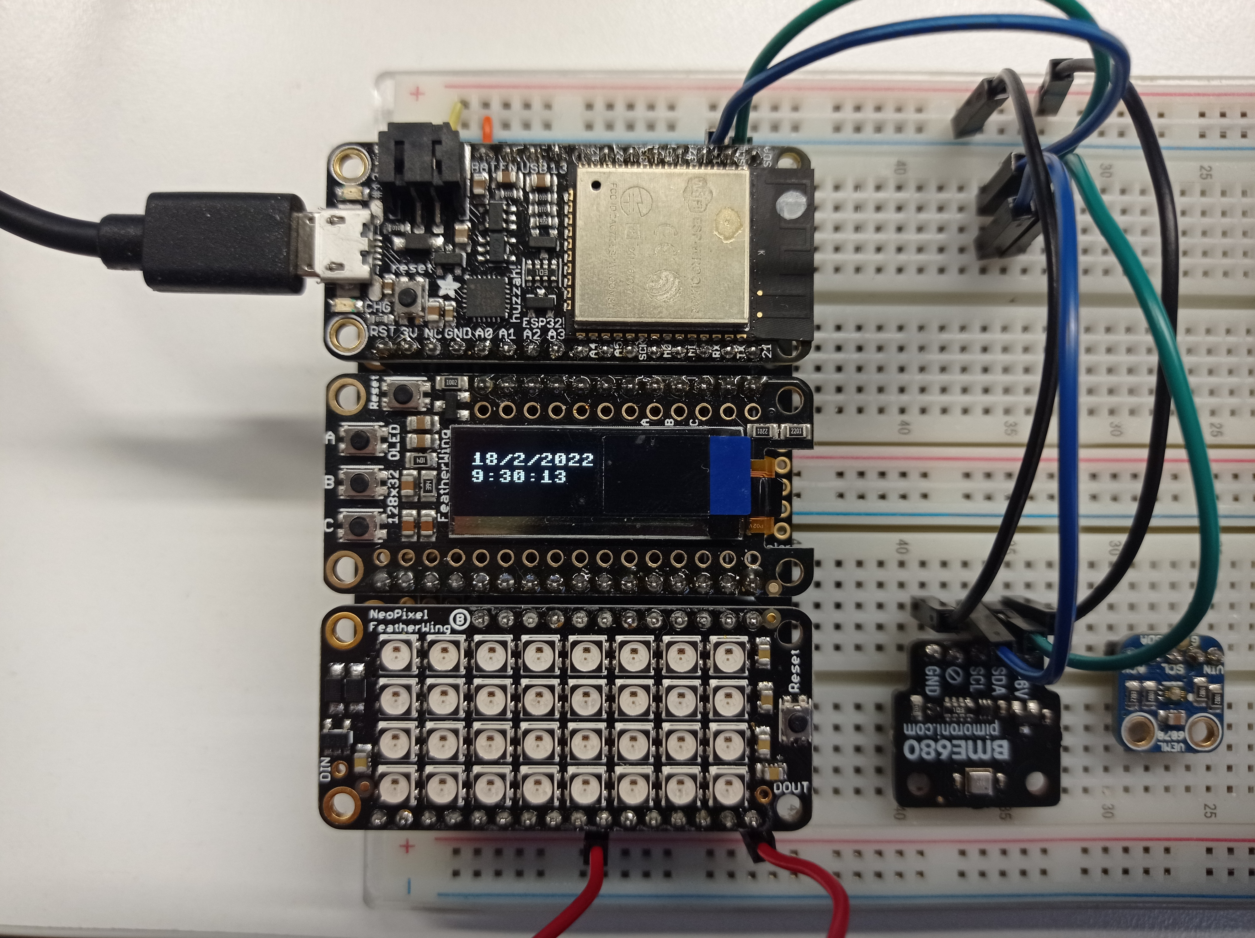

Now to start an access period, you need to press the button **A**, the buttons are labelled from A to C on the left of the screen.

When the access period is started, the LEDs should light up green and the screen should start counting how many seconds the access period has lasted, as you can see in the image below.

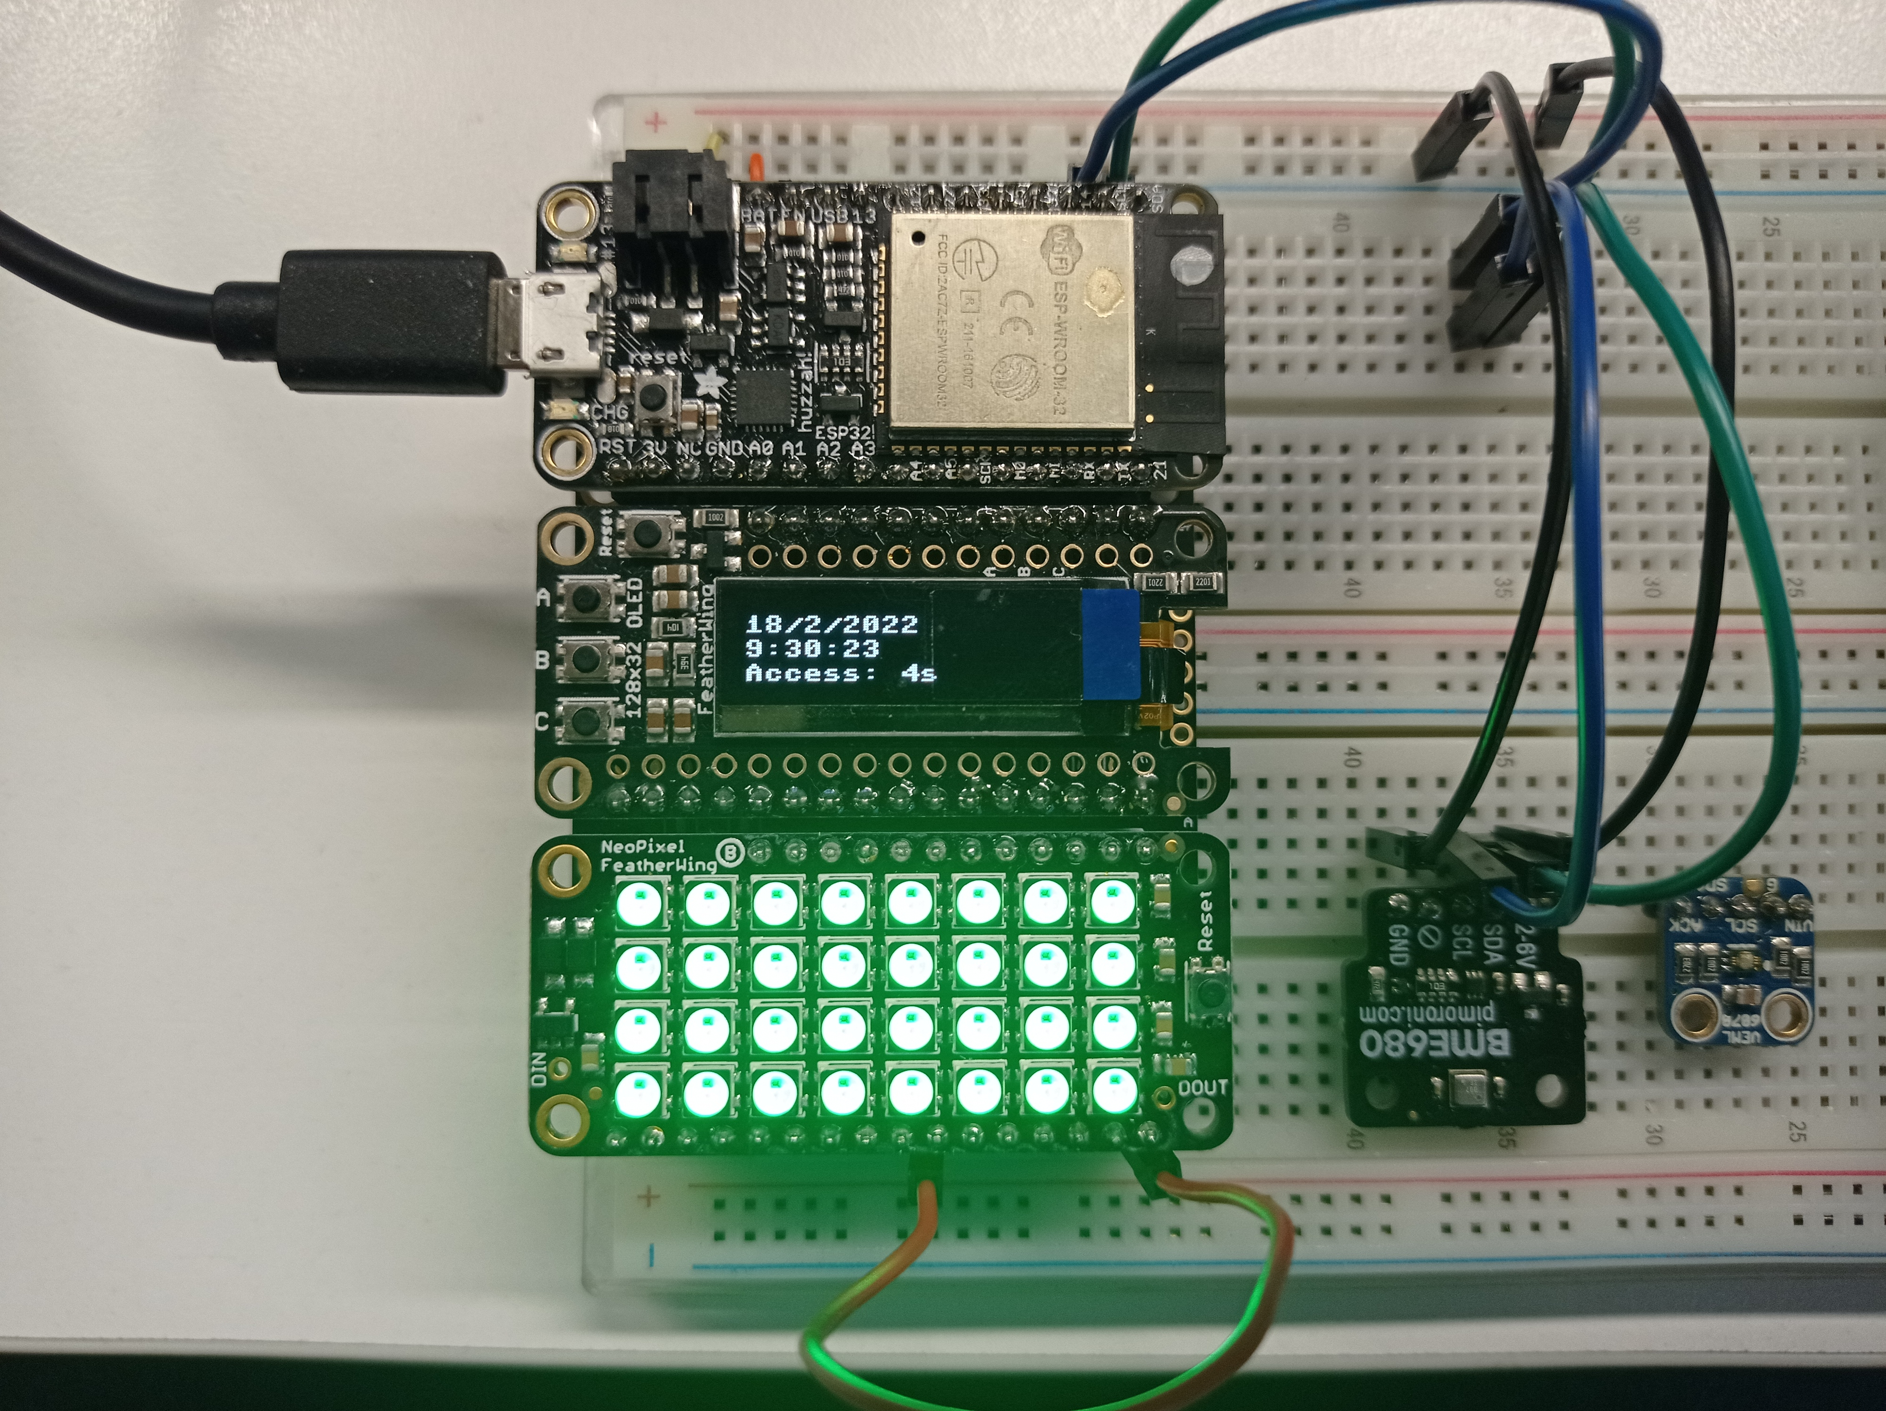

Now that the access period started, the Huzzah32 is now logging data from the sensors connected to it on the right.

After the access period reaches ~10 seconds, the LEDs will turn red, as you can see in the picture below.

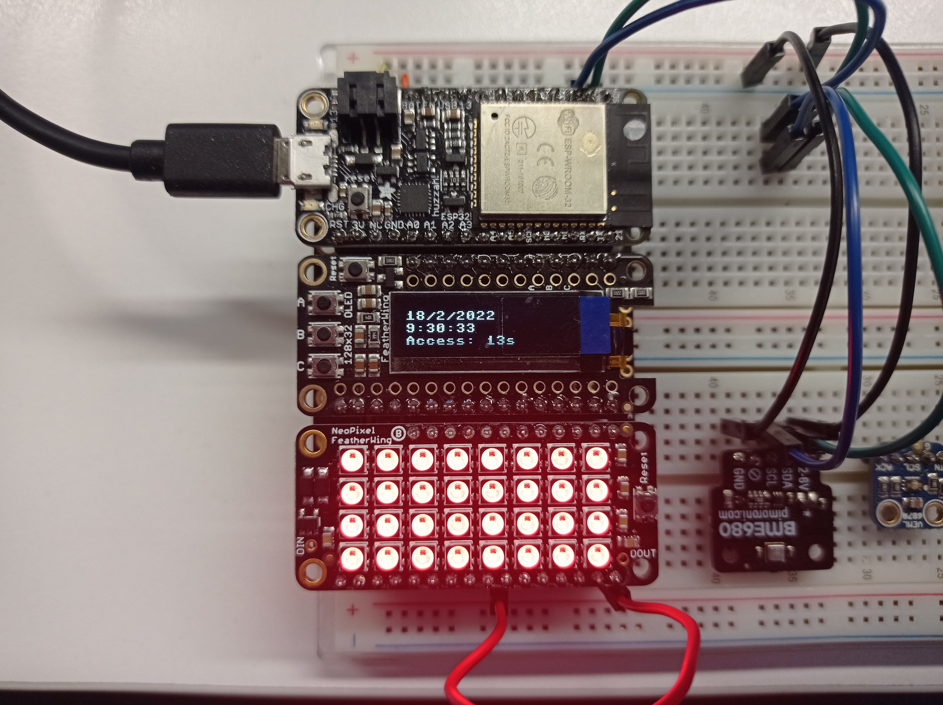

You can press the button **B** whenever you want to finish the access period, this will save the access period total time into the log file, and the LEDs should turn off.

To stop the Huzzah32 operation, press the button **C**.

This will show a message in the IoT VM command prompt as you can see below.

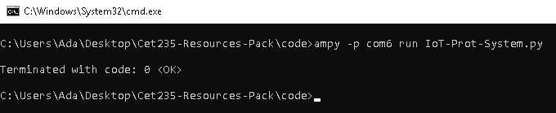

Now we can retrieve the logged data from the Huzzah32, to do that, enter the following code in the command prompt.

**ampy –p com?? get IoT-Data.csv IoT-Data.csv**

When the file is extracted from the Huzzah32 to the IoT VM, the command prompt will not return any message, but it will have the input field show up again.

When the file is extracted to the VM, you will see the file inside the same folder as the code.

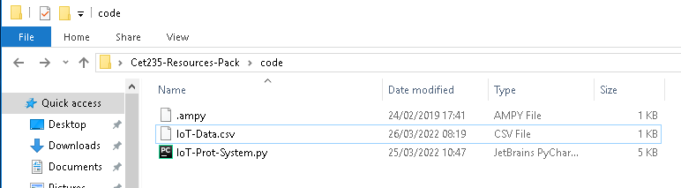

Now to get the data from the csv log file, enter this command into the command prompt:

**py IoT-Desktop-App.py**

This will print out all the data points as follows:

Date | Time | Temperature | Humidity

It will also show the date and time of the access periods, as well as how long they lasted.

